Logging and Changing your Profile (and password)

HOW TO LOGIN

To login to the course site, please be sure you have the correct site address. We have one for each cycle:

Cycle 1: http://aquinas1.classrunner.com

Cycle 2: http://aquinas2.classrunner.com

Cycle 3: http://aquinas3.classrunner.com

(K-12/ALH): http://al.classrunner.com

Please click on the Login button to enter the course site.

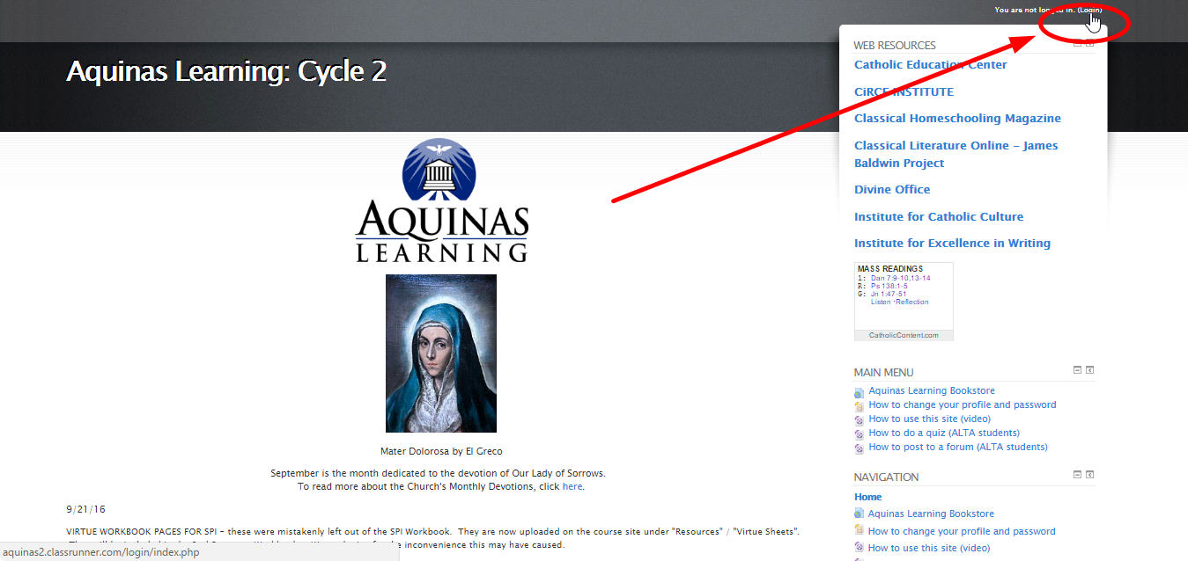

You will be prompted for your username and password to enter the secure course site. Please note these are all small letters and no spaces or special characters are used.

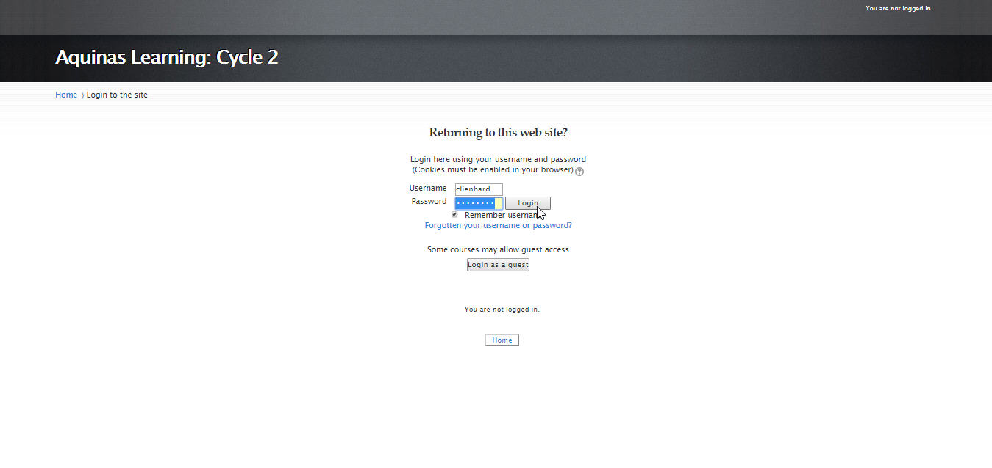
Your USERNAME is usually first name initial last name (e.g. clienhard). If two people in your family have the same first initial, we move to first and second letter of your first name and your last name (e.g. colienhard).

Your PASSWORD is aquinas.

You can changes these once you are into the course site

HOW TO CHANGE YOUR PROFILE AND PASSWORD

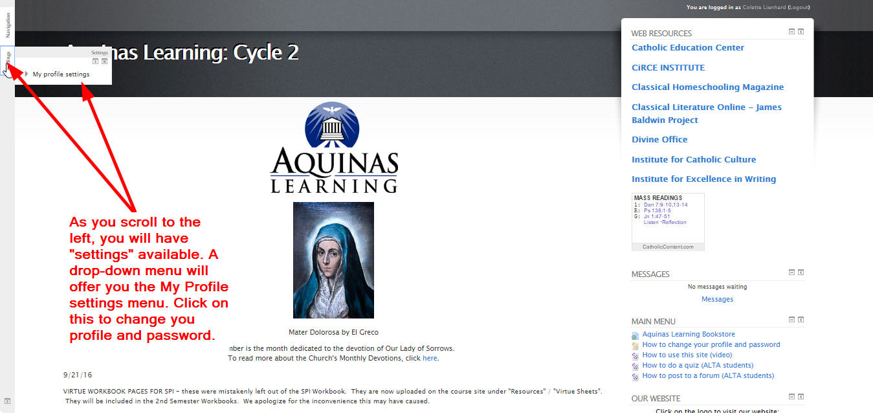

The My Profile Settings Menu

From the My Profile Settings menu, you can change your profile and password. We have it set so that your email is private. If you wish to share your password, you will need to change this here in your profile settings.

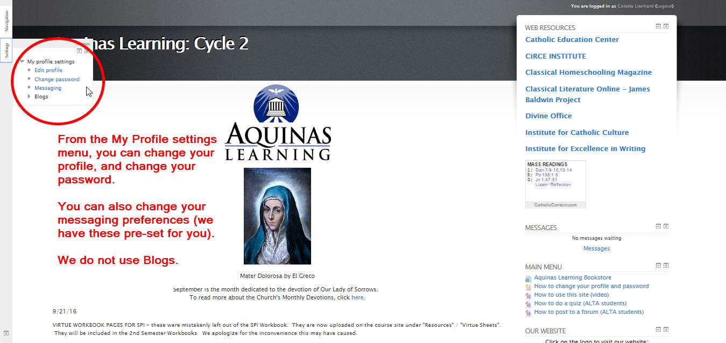

Your profile settings is where you can change your name (e.g. if you wish to not have “Jennifer” listed as your name, but “Jen” or if there is a typo in your name (my sincere apologies) you can correct the spelling here.)

The fields in RED are required.

You may add a photo, but we request that it is a small sized image.

Aquinas Learning asks that PARENTS approve any images that their ALTA students upload, and strongly recommends not uploading photographs of minors.

ALTA STUDENTS do not have email accounts associated with their profiles. They are set up with a “@nomail.com” account. You may wish to connect a real email account with their profile. Aquinas Learning asks that if a minor wishes to contact a Mentor, that they please copy the parent into the email, so they may read the correspondence.

Parents have access to all the ALTA courses, so they may be familiar with the course work and read all the public forums. There should be no private correspondence without parental involvement.

YOUR PROFILE

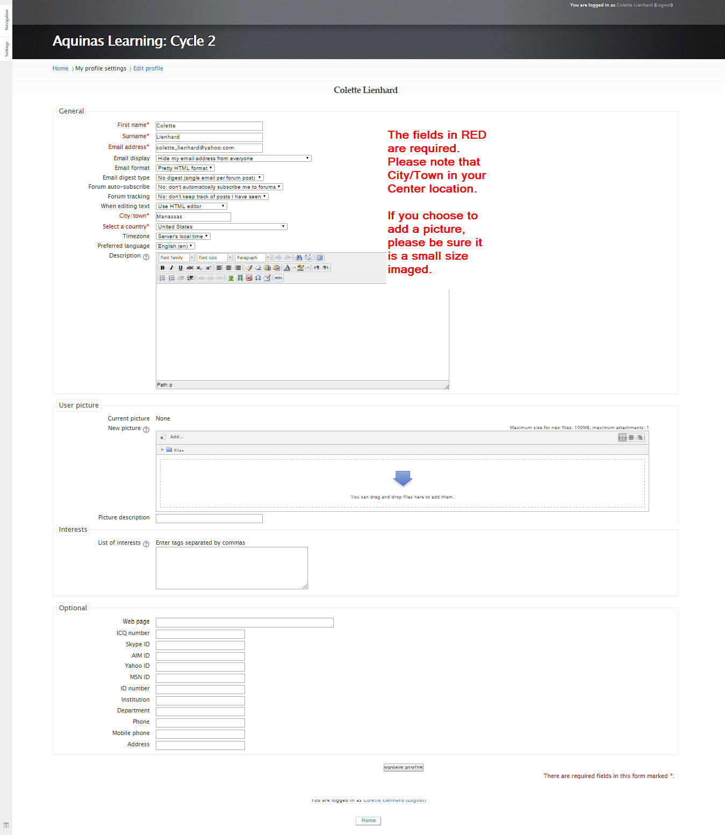

CHANGING YOUR PASSWORD
To change your password, you may select the My Profile Settings Menu and click on the Change password option. You will be prompted to enter your old password “aquinas” and to enter a new password. Please note that if you change your password, we cannot tell you what it is if you forget it.

Aquinas Learning recommends that ALTA students not change their passwords, so parents can access their child’s accounts to see the gradebooks.

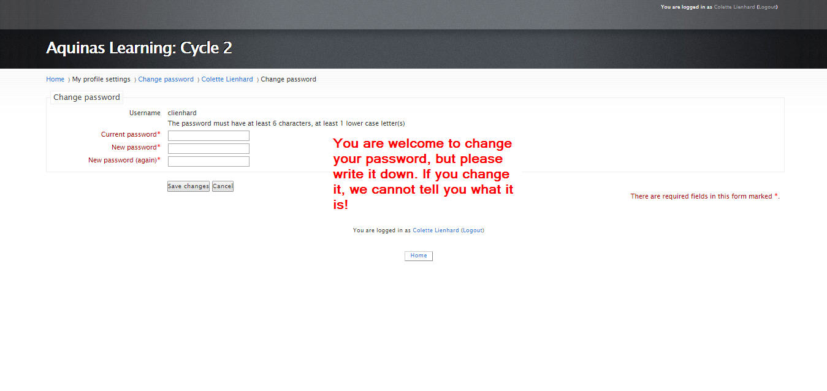

To return to the Home Page
To return to the home page, click on “Home” in the menu bar, and you’re ready to go!

