HOW TO USE THE COURSE SITE

To enter your course(s), please click on the Course Title. I will use Prima 1 as an example, but each course is set up the same, with each week presented within a contained “box”. You will need to scroll down (using the bar at right) to find the current week’s materials.

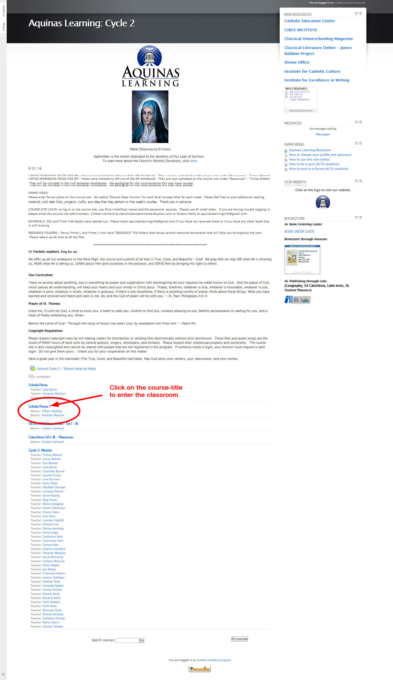

Once you are inside the course, you will see a “box” for each week’s class.

At the top of the course materials are common resources that you will use throughout the year.

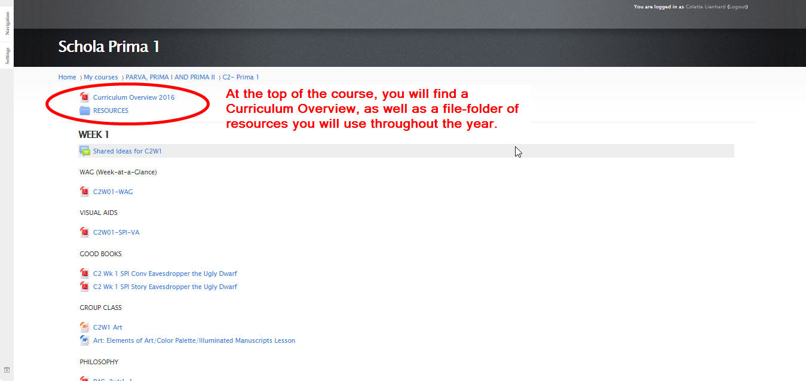

Each Week will have a list of files or “links”. As you click on each file, it will open.

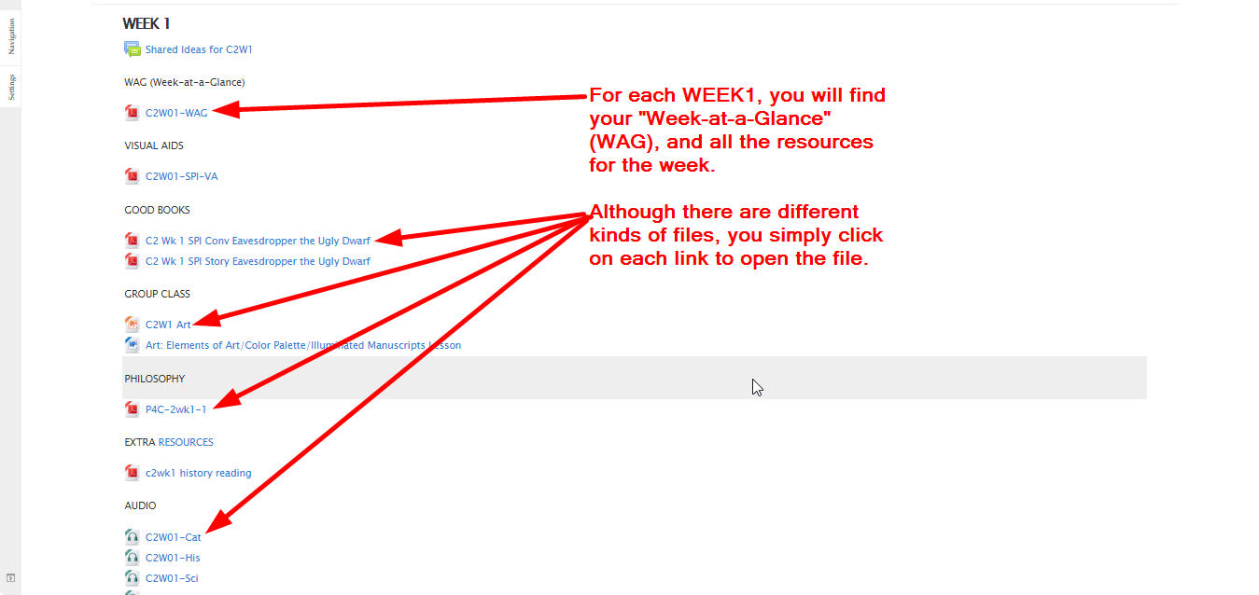

The Forum is where you may share ideas.

The forum is a public message board, so please do not use this for private messages. When you click on this link, you will be prompted to add to the discussion.

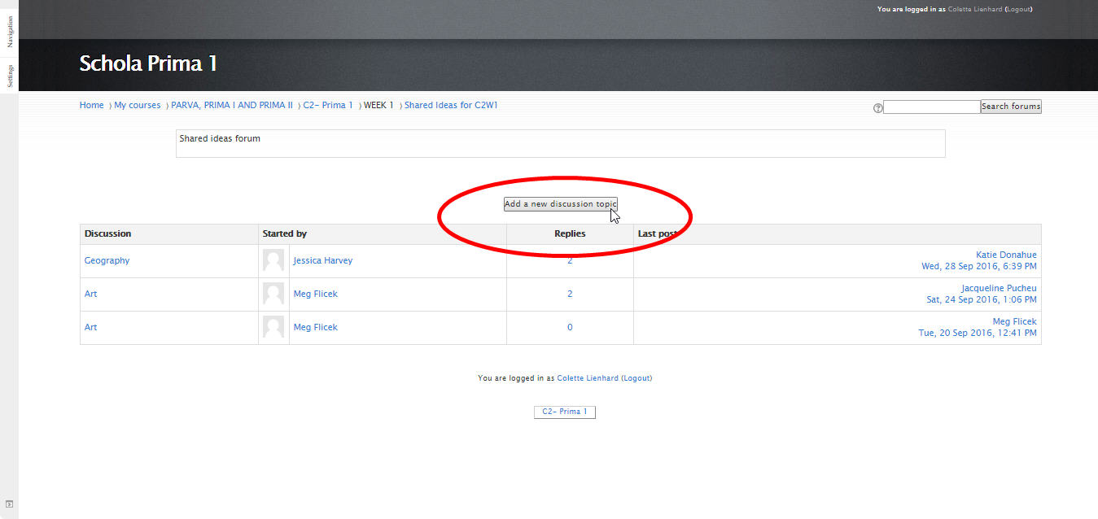

At the top, you will see what the Discussion is about. You can add to the conversation, or click on the posts listed to read what others have written.

HOW TO ADD TO A FORUM.
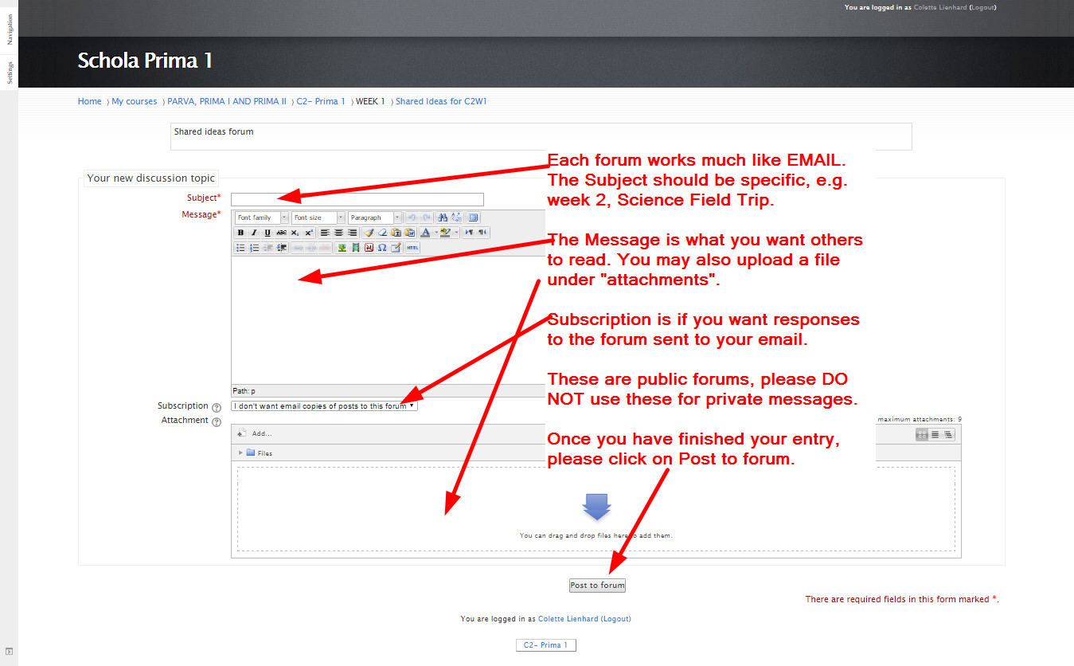

For each Forum, you will need a subject line. Please be specific, such as Week 2, Science Field Trip suggestion.

The Message is where you will write your materials. You can add a file using the Attachment box below.

Subscription is where you can choose to have responses to your forum sent to your email account.

Once you have finished, be sure to click on “Post to Forum” or it will be lost. You post will then appear in the list below the Add to Discussion button.

With the forums, you may read other people’s posts and reply to them, just as you would with email. Your response will be in the same format as an original post.
Some files, when you open them, will download. Word and PowerPoint files will open in these programs if you have them on your computer. Otherwise, they will open in readers.

You will see the file download at the bottom left of your screen. When you click on this, it will open in your computer.
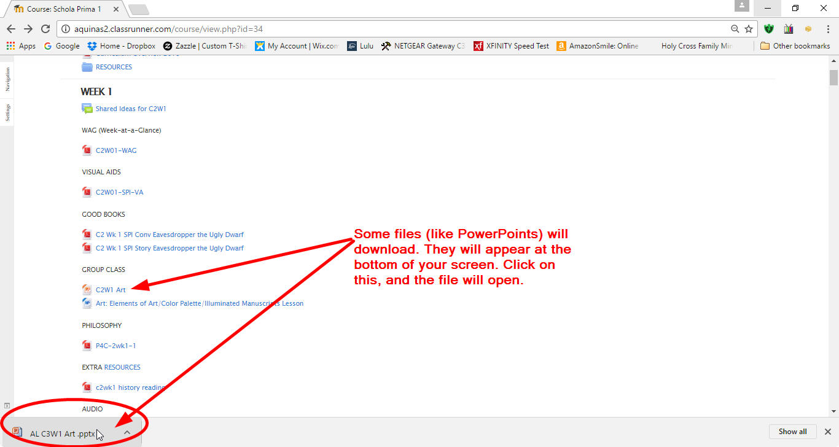

Once the file is opened, you will have full access to the file.

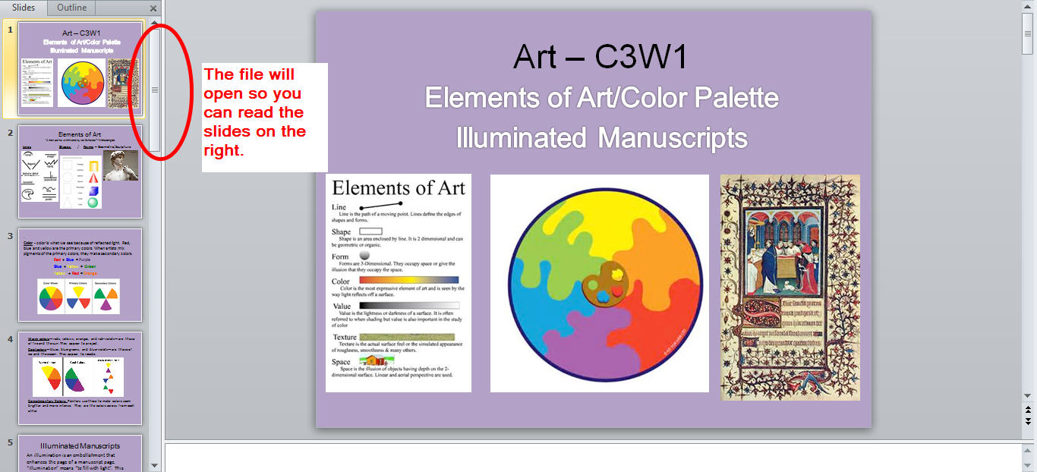

You can always scroll through the materials.

Audio files will open in the course site. When you click on the link, it will open in the screen.

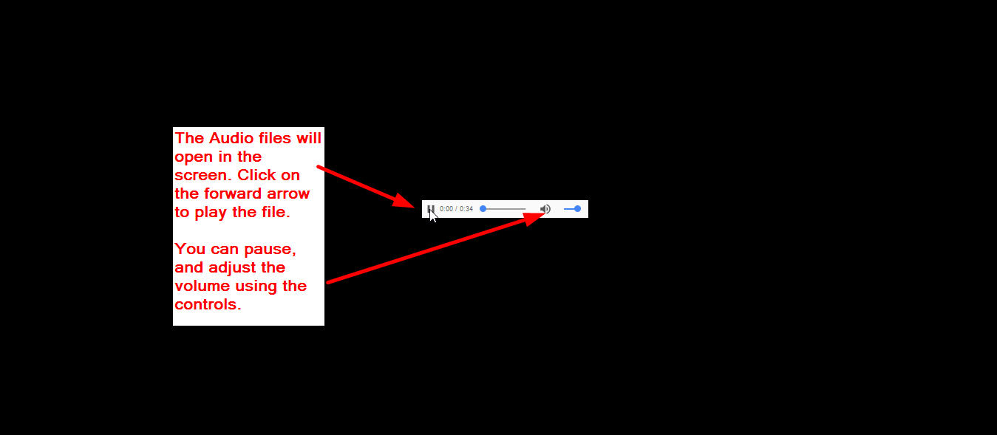

You can play, pause, increase the volume and replay (by dragging the blue dot back to the beginning along the slide bar).

From any kind of file, you may always return to the main course with the back arrow at top.

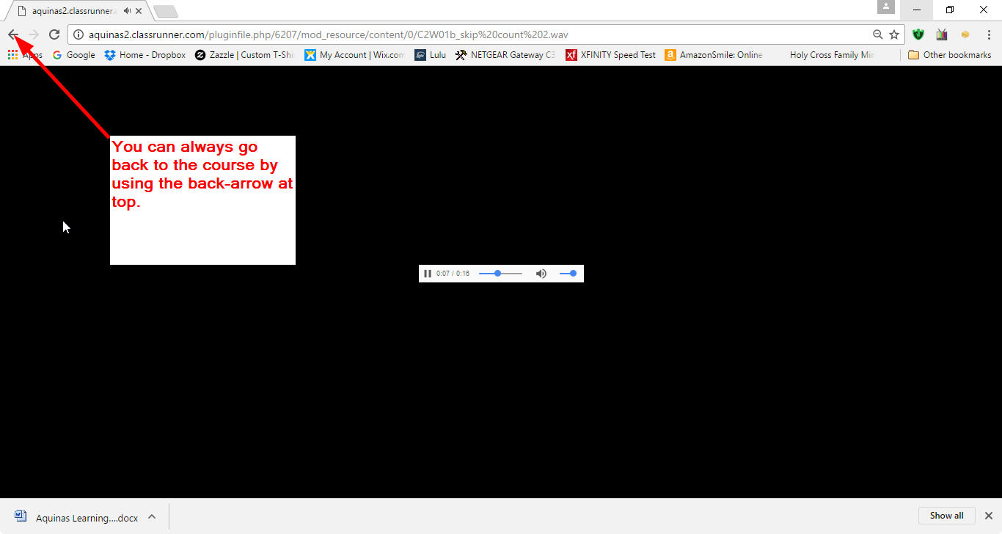

Finally, to return to the shell of the course site, you can use the Menu bar at top.

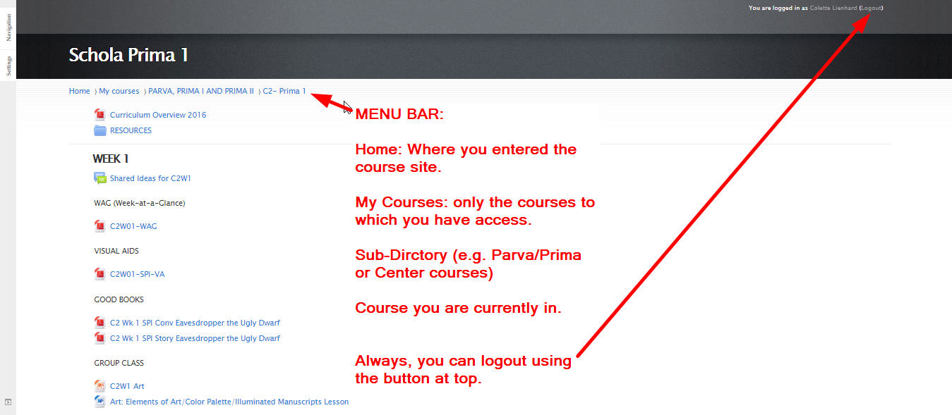

If you have questions, or problems along the way, you can always email me at:

catholiceducationcenter@yahoo.com

I hope this helps!
Colette

